**3.5 Graph Neural Networks in Biomedicine**

Petro Lio, Paul Scherer, Emma Rocheteau, Andreea Deac, Nikola Simidjievski

[pl219@cam.ac.uk](mailto:pl219@cam.ac.uk)

<https://www.cl.cam.ac.uk/teaching/2122/L45/>

**General tour of GNN**

* Mathematical Formulation
  + Graphs: nodes (objects) + edges (interactions) between them
* Types of graphs
  + Undirected
  + Weighted
  + Multirelational
  + Heterogeneous
* Euclidean to non-Euclidean perspective
  + Increased interpretability
  + Better concentration of information
  + E.g. Superpixel
* Tasks on a graph: by scale
  + Node-level labels
  + Edge-level labels
  + Graph-level labels
  + Using neural network - use appropriate loss function
    - E.g. cross-entropy for classification or mean-squared error for regression
    - Optimise by gradient + backpropagation
  + Existing libraries:
    - PyTorch Geometric,
    - DGL
    - Spektral,
    - Jraph
* Formalization of Graph embedding
* Encoder-decoder Setup
  + Encode node
  + Decode neighborhood
* How a GNN operates
  + Input: Feature matrix X, preprocessed adjacency matrix A
  + Output:
    - Node classification:
      * softmax(z)
      * E.g. Kipf & Welling (ICLR 2017)
    - Graph classification:
      * softmax(sum z)
      * E.g. Duvenaud et al. (NIPS 2015)
    - Link prediction:
      * p(A) = sig(zz)
* Cancer Graph Network
  + <https://www.medrxiv.org/content/10.1101/2021.09.01.21262086v2>
* Multilayer networks
  + Not so much different to other networks
  + Adjacency matrix as a single matrix
* Directional graph neural networks
  + Grid Graph
  + Molecular graph
* Higher Order networks
  + Hypergraph
  + Multi-to-multi nodes
  + <https://www.nature.com/articles/s41567-021-01371-4>
* Systemic level signal detection
  + Multi-organ, multi-omics
  + Modelling connection between layer is complex
  + Hypergraph
    - <https://www.biorxiv.org/content/10.1101/2022.07.31.502211v3>
* Sheaf Neural Networks
  + <https://arxiv.org/pdf/2206.08702.pdf>
  + <https://arxiv.org/pdf/2202.04579.pdf>

**Towards understanding mechanisms: adding logics**

* <https://arxiv.org/pdf/2007.04612.pdf>

**ODEs and deep learning**

**Digital Patient**

* <https://arxiv.org/pdf/2009.08299.pdf>
* Better understanding systemically

**From MLPs to GNNs for learning in biomedical contexts**

Geo2DR: https://github.com/paulmorio/geo2dr

PyG-T: https://github.com/benedekrozemberczki/pytorch_geometric_temporal

**Predicting Patient Outcomes - EHR in ICU**

* Electronic Health Records in the ICU
  + <https://arxiv.org/abs/2101.03940>
* Distribution of diagnoses in eICU database
  + Mean frequency with each diagnosis in data – 229 patients
    - Not sufficient for DL algorithm
  + Traditionally
    - Only use common diagnoses – excluding rare diseases
    - Encoding layer to reduce dimension
  + Adopted to doctor’s
    - How to learn from rare patient cases from doctors
      * Relatedness
* Relatedness
  + Doctor recalling how they treated rare cases in the past
    - Compare how new patient is similar and different from the past
    - Emulated to architecture
  + New representation for each patient
* Graph construction
  + Word embeddings from word2vec/ LightBERT followed by cosine similarity
  + New similarity matrix
    - Constructed with other clinicians

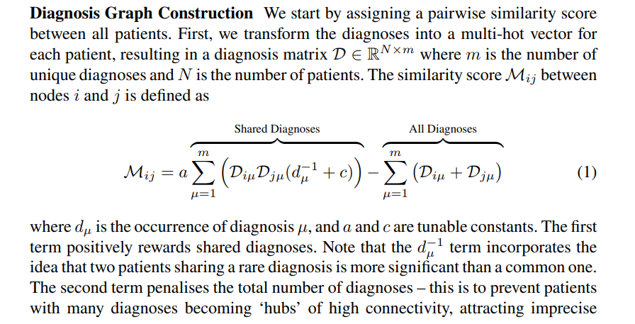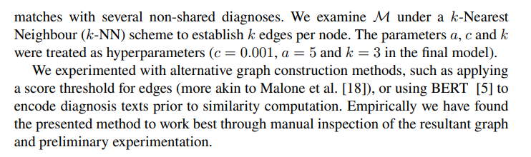

* + - 1st dimension: index of patient
    - 2nd dimension: index of diagnosis
    - D = long diagnosis factors
    - Taking *k* nearest neighbour to construct graph

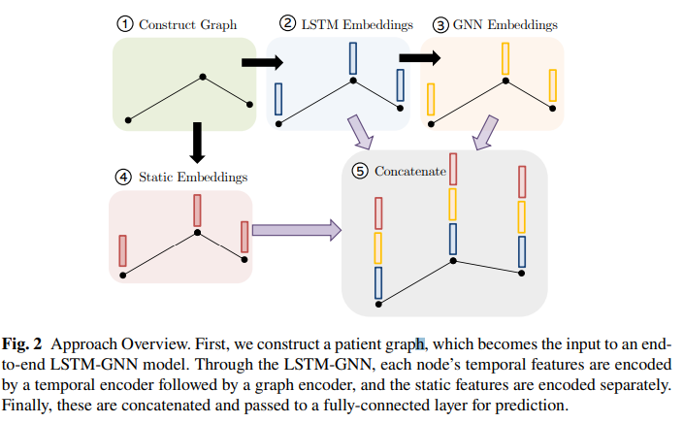

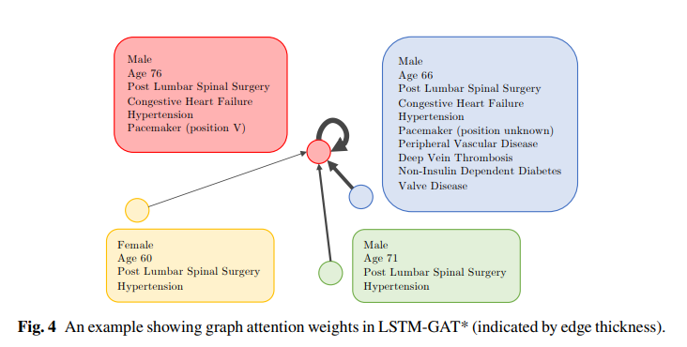

**Inductive biases for molecular interactions**

* Molecular interactions: Infer the bipartite links between graphs
  + Antibody-antigen interactions
    - <https://arxiv.org/abs/1806.04398>
    - <https://arxiv.org/abs/2106.00757>
* Motivation for studying antibodies
  + Antibodies are
    - Y-shaped proteins
    - Critical part of our immune system
  + Neutralise pathogenic bacteria and viruses by tagging the antigen
    - “Lock and key” system
  + Designing antibodies would be a big step towards personalised medicine
* Towards personalised medicine
  + Generating an antibody requires first predicting the specific amino acids (the paratope) which participate in the neutralisation of the antigen
  + Input:
    - A sequence of (one-hot encoded) antibody amino acids
    - +) A sequence of (one-hot encoded) antigen amino acides
  + Output:
    - Probability for each amino acid to participate in binding with the antigen

**Common challenges in practice: real data from clinical cancer trials**

* Multimodal and high dimensional data
  + Complex models dont scale nor transfer
  + Sophisticated approaches need substantial amount of data (samples) for training
* OntoGCN

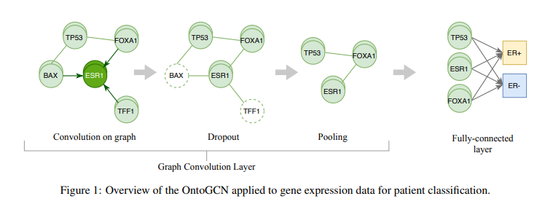

* + <https://arxiv.org/pdf/2011.10998.pdf>
  + Each patient is a graph instance
    - Node: 3 different ontologies
    - Edges: k nearest genes
  + Improved performance over graph-based and non-graph-based baselines on different tasks of cancer subtyping even with low data regimes (100s)

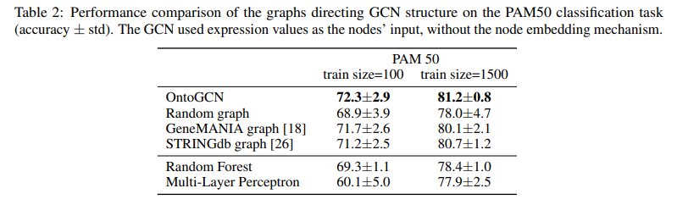

* + Feature selection setting
* Diet approaches: GRL for network parametrization

**Readings:**

<https://web.stanford.edu/class/cs224w/>